Joint Photographic Experts Group (JPEG) is compression algorithm for photos. JPEG created for Professional photographers. The JPEG compression algorithm is at its best on photographs and paintings of realistic scenes with smooth variations of tone and color. For web usage, where the amount of data used for an image is important, JPEG is very popular. JPEG/Exif is also the most common format saved by digital cameras. The degree of compression can be adjusted, allowing a selectable tradeoff between storage size and image quality. JPEG typically achieves 10:1 compression with little perceptible loss in image quality.

*“The JPEG standard (ISO/IEC 10918) was created in 1992 (latest version, 1994) as the result of a process that started in 1986. Though, this standard is generally considered as a single specification, in reality it is composed of four separate parts and an amalgam of coding modes.”*

***“Storage Size is Down So İmage Quality is Down”***

Effects of JPEG compression

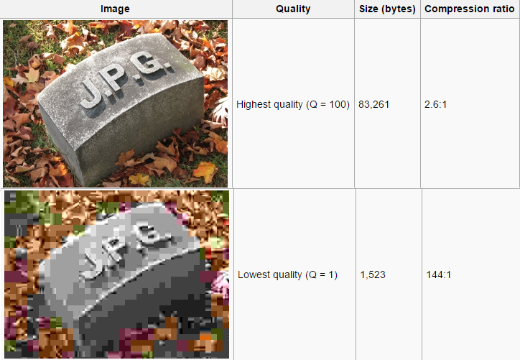For information, the uncompressed 24-bit RGB bitmap image below (73,242 pixels) would require 219,726 bytes (excluding all other information headers). The filesizes indicated below include the internal JPEG information headers and some meta-data. For highest quality images (Q=100), about 8.25 bits per color pixel is required. The image at lowest quality uses only 0.13 bit per pixel, and displays very poor color. This is useful when the image will be displayed in a significantly scaled-down size.